1.
//FirstTest.java

package com.im;

import org.junit.jupiter.api.Test;
import org.junit.jupiter.api.function.Executable;//FirstTest.java
import java.math.BigDecimal;
import java.util.ArrayList;
import java.util.Arrays;
import java.util.List;
import static org.junit.jupiter.api.Assertions.*;

public class FirstTest {
First first = new First();
@Test
void should_Return_Equal_If_String_Replaced(){
//given
String mainStr = "Java is bad";
String subStr = "bad";
String repStr = "good";
String expectedStr = "Java is good";

//when
String generatedStr = first.replaceSubString(mainStr,subStr,repStr);

//then
assertEquals(expectedStr,generatedStr);

}
@Test
void should_Return_Equal_If_String_Null(){
//given
String mainStr = "Java is good";
String subStr = null;
String repStr = null;
String expectedStr = "Java is good";

//when
String generatedStr = first.replaceSubString(mainStr,subStr,repStr);

//then
assertEquals(expectedStr,generatedStr);

}
@Test
void should_Return_Equal_if_List_Filtered(){
//given
List<Integer> list = new ArrayList<>(Arrays.asList(1,2,3,5,6,7,8,9));
List<Integer> expList = new ArrayList<>(Arrays.asList(1,3,5,7,9));

//when
List<Integer> generatedList = first.filterEvenElements(list);

//then
assertEquals(expList,generatedList);

}
@Test
void should_Return_Equal_If_Average_Calculated(){
//given
List<BigDecimal> decimalList = new ArrayList<BigDecimal>();
decimalList.add(BigDecimal.valueOf(5.5));
decimalList.add(BigDecimal.valueOf(5.5));
decimalList.add(BigDecimal.valueOf(5.5));
decimalList.add(BigDecimal.valueOf(5.5));
BigDecimal expectedAvg = BigDecimal.valueOf(5.5);

//when
BigDecimal avg = first.calculateAverage(decimalList);

//then
assertEquals(expectedAvg,avg);
}
@Test
void should_Throw_Runtime_Exception_When_List_Empty(){
//given
List<BigDecimal> list = new ArrayList<>();

//when
Executable executable = () -> first.calculateAverage(list);

//then
assertThrows(RuntimeException.class,executable);

}
@Test
void should_Return_True_If_String_Palindrome(){
//given
String originalStr = "madam";

//when
boolean answer = first.isPallindrome(originalStr);

//then
assertTrue(answer);

}

}
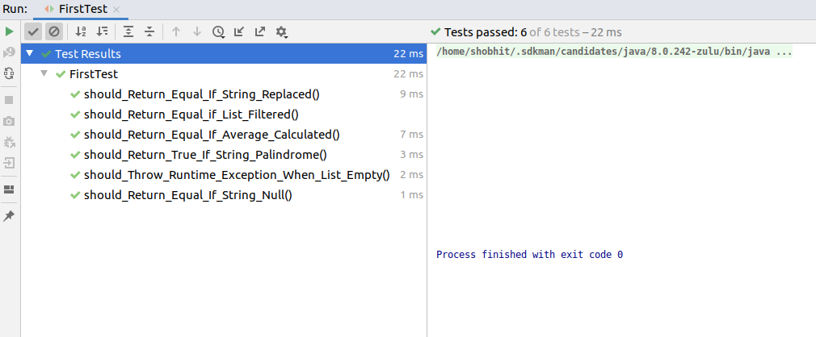

2.
//BMICalculatorTest.ajava

package healthycoderapp;

import org.junit.jupiter.api.Test;
import org.junit.jupiter.api.function.Executable;

import java.util.ArrayList;
import java.util.List;

import static org.junit.jupiter.api.Assertions.*;

class BMICalculatorTest {

@Test
void should_Return_True_If_diet_Recommended(){
//given
double weight = 89.0;
double height = 1.72;

//when
boolean recommended = BMICalculator.isDietRecommended(weight,height);

//then
assertTrue(recommended);

}
@Test
void should_Return_False_If_diet_Not_Recommended(){
//given
double weight = 50.0;
double height = 1.92;

//when
boolean recommended = BMICalculator.isDietRecommended(weight,height);

//then
assertFalse(recommended);

}
@Test
void should_Throw_Arithmetic_Exception(){
//given
double weight = 50.0;
double height = 0.0;

//when
Executable executable = () -> BMICalculator.isDietRecommended(weight,height);

//then
assertThrows(ArithmeticException.class,executable);
}
@Test
void should_Return_Coder_With_Worst_BMI_When_List_Not_Empty(){
//given
List<Coder> list = new ArrayList<>();
list.add(new Coder(1.80,60.0));
list.add(new Coder(1.82,98.0));
list.add(new Coder(1.82,64.7));

//when
Coder coderWorstBMI = BMICalculator.findCoderWithWorstBMI(list);

//then
assertAll(
() -> assertEquals(1.82,coderWorstBMI.getHeight()),
() -> assertEquals(98,coderWorstBMI.getWeight())
);

}
@Test
void should_Return_Null_When_List_Empty(){
//given
List<Coder> list = new ArrayList<>();

//when
Coder coderWorstBMI = BMICalculator.findCoderWithWorstBMI(list);

//then
assertNull(coderWorstBMI);
}
@Test
void should_Return_List_Of_Scored_When_Coder_List_Not_Empty(){
//given
List<Coder> list = new ArrayList<>();
list.add(new Coder(1.80,60.0));
list.add(new Coder(1.82,98.0));
list.add(new Coder(1.82,64.7));
double expected[] = {18.52,29.59,19.53};

//when
double bmiScores[] = BMICalculator.getBMIScores(list);

//then
assertArrayEquals(expected,bmiScores);

}

}
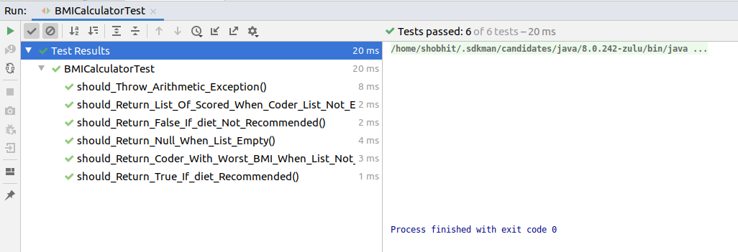

//DietPlaanerTest.java

package healthycoderapp;

import org.junit.jupiter.api.BeforeEach;
import org.junit.jupiter.api.Test;
import org.junit.jupiter.api.function.Executable;

import static org.junit.jupiter.api.Assertions.*;

class DietPlannerTest {
private DietPlanner dietPlanner;
DietPlanner dp = new DietPlanner(10,50,40);

@BeforeEach
void setup(){
this.dietPlanner = new DietPlanner(20,30,50);
}
@Test
void should_Throw_Exception_If_Sum_Not_Hundred(){
//given
int proteinPercentage = 30;
int fatPercentage = 40;
int carbohydratePercentage = 20;
//when
Executable executable = () -> new DietPlanner(proteinPercentage,fatPercentage,carbohydratePercentage);

//then
assertThrows(RuntimeException.class,executable);

}
@Test
void should_Return_Correct_Diet_Plan_When_Correct_Coder(){
//given
Coder coder = new Coder(1.82,75.0,26,Gender.MALE);
DietPlan expected = new DietPlan(2202,110,73,275);

//when
DietPlan actual = dietPlanner.calculateDiet(coder);

//then
assertAll(
() -> assertEquals(expected.getCalories(),actual.getCalories()),
() -> assertEquals(expected.getProtein(),actual.getProtein()),
() -> assertEquals(expected.getFat(),actual.getFat()),
() -> assertEquals(expected.getCarbohydrate(),actual.getCarbohydrate())
);

}

}

